Logistic Regression

Business Problem – Credit Risk Detection
Bank customers seek loans from the bank promising to repay the loan in installments over a determined period and with some interest on the amount. However, banks are always at risk because many customers will not be able to repay the amount and will default on their loans. This can cause big losses to the bank. Therefore, analyzing credit risk is of utmost importance for the bank where the bank analyzes customers’ information and credit history before deciding to grant the loan. Logistic Regression can be used to build predictive modeling to predict how likely a customer is to default the repayment of the loan.

Revisiting Regression
Regression analysis is used to predict the value of a dependent variable based on the value of at least one or more independent variable (s). Explain the impact of changes in an independent variable on the dependent variable.
• Dependent variable: the variable we wish to explain usually denoted by Y.
• Independent variable(s): the variable(s) used to explain the dependent variable. Denoted by X.

Classifying with Linear Regression
Our output variable is Credit Default in the dataset which is either 0 or 1.

Trying to fit in a best fit regression line.

Where is the problem?
1st, we know our dependent variable is limited to the interval [0,1] because we have 2 classes default or no-default. 2nd, Linear Regression is designed to solve the problem of minimizing the Squared Error, which does not seem to be an appropriate fit in this case. Our goal is to find a way to separate the 2 classes – default or no-default and not to minimize the squared error against the best fit line.

Probability & Odds

Odds
Recall the definitions of Odds:

odds = p
_____
1 - p

The odds have a range of 0 to ∞ with values greater than 1 associated with an event being more likely to occur than not to occur and values less than 1 associated with an event that is less likely to occur than not occur. The logit is defined as the log of the odds:
ln(odds) = ln (p/1-p) = ln(p)-ln(1-p)

This transformation creates a variable with a range from -∞ to +∞. It solves the problem we encounter in fitting a linear model to probabilities. As probabilities (the dependent variable) only range from 0 to 1, we can get linear predictions that are outside of this range.

Odds Ratio
Any odds ratio, by definition, is a ratio of two odds, written here as OddsY divided by OddsX, in which the subscripts indicate two individuals or two groups of individuals being compared.
Odds Ratio(OR) = Odds_{y}
________
Odds_{x}

So, if the outcome is the same in both groups, the ratio will be 1, which implies there is no difference between the two groups of individuals.
However:
• If the OR is > 1, then group X is better than group Y
• If the OR is < 1, then group Y is better than group X

Why Use Odds Ratio?
The problem is that Probability and Odds have different properties that give Odds some advantages. For example, in logistic regression, the Odds Ratio represents the constant effect of a predictor X, on the likelihood that one outcome will occur.
In regression models, we often want a measure of the unique effect of each X on Y. If we try to express the effect of X on the likelihood of a categorical Y having a specific value through Probability, the effect is not constant. That means there is no way to express in one number how X affects Y in terms of Probability. The effect of X on the probability of Y has different values depending on the value of X. We will not be able to describe that effect in a single number using Probability (although it is intuitive) and will have to use Odds Ratio.

Introduction to Logistic Regression
Logistic regression is used to analyze relationships between a dichotomous dependent variable and categorical or numerical independent variables. Logistic regression combines the independent variables to estimate the probability that a particular event will occur, i.e., a subject will be a member of one of the groups defined by the dichotomous dependent variable.
The value produced by logistic regression is a probability value between 0.0 and 1.0.
If the probability for group membership in the modeled category is above some cut point (the default is 0.50), the subject is predicted to be a member of the modeled group. If the probability is below the cut point, the subject is predicted to be a member of the other group.
f(x) = p(y=1) = e^{x}/(e^{x}+1)

Where x is a linear combination of independent variables.

Logit Model
The "logit" model: ln[p/(1-p)] = B0 + B1X
• p is the probability that the event Y occurs, p(Y=1) [range=0 to 1]
• p/(1-p) is the "odds ratio" [range=0 to ∞]
• ln[p/(1-p)]: log odds ratio, or "logit” [range=-∞ to +∞]

Generalized Linear Models

Response Variable Predictor Variables

Logistic Regression belongs to a class of models known as GLM. GLMs have 3 characteristics:
• Involves a linear combination of independent variables
• The dependent variable has an underlying probability distribution
• Mean of the output distribution is related to the linear combination of the independent variable by way of a function, known as link function

The Logistic Regression Model
Linear Regression:
y = 𝛂 + 𝛃1X1 + 𝛃2X2 + 𝛃3X3 + 𝛃4X4 + … + 𝛃nXn + 𝛆

Logistic Regression:
ln(p/1-p) = 𝛂 + 𝛃1X1 + 𝛃2X2 + 𝛃3X3 + 𝛃4X4 + … + 𝛃nXn
ln(odds) = 𝛂 + 𝛃1X1 + 𝛃2X2 + 𝛃3X3 + 𝛃4X4 + … + 𝛃nXn

Interpreting Coefficients in Logistic regression
RHS of both Linear Regression & Logistic Regression looks the same except the error in case of Linear regression. In the case of Logistic Regression, the LHS has the logit function. So, we cannot interpret our regression coefficients the same way as Linear Regression.

In Logistic regression, a unit increase in feature X1 results in multiplying the odds ratio by an amount of ex. So, if a coefficient is positive, then we multiply the odds ratio by a number > 1, so we know that increasing the feature of X1 will effectively increase the probability of the output being labeled as class 1.

On the other hand, if a coefficient is negative, increasing the feature will shift the balance towards predicting class 0

Assumptions of Logistic Regression
• Makes fewer assumptions that Linear Regression
• The non-linear transformation of the logistic function means that we can model more complex dependent-independent relationships
• We have no assumption on normal distribution for residuals
• No homoscedasticity assumption

Maximum Likelihood Estimation
In Linear Regression, we got our coefficients by minimizing the sum of squared error terms. For Logistic Regression, we do this by maximizing the likelihood of the data. The likelihood function is the product of all the individual likelihoods for each data point given by,
l(𝛃1, 𝛃2, 𝛃3, 𝛃4, .., 𝛃n) = Π p(y=1) . Π 1-p (y=1)
The idea is to choose our regression coefficients so that the likelihood function is maximized.

Logistic Regression Variable Requirements
Logistic regression analysis requires that the dependent variable be dichotomous. Logistic regression analysis requires that the independent variables be numerical or dichotomous. If an independent variable is nominal level and not dichotomous, we need to dummy code the variable. Logistic regression does not make any assumptions of normality, linearity, and homogeneity of variance for the independent variables.

Parameters to Evaluate
• Deviance
• R-Square
• Coefficients and their p-values
• Akaike Information Criterion (AIC)
• Gini Index
• Fisher Information
• Confusion Matrix
• ROC Curve
• Sensitivity & Specificity
• Hosmer-Lemeshow Goodness-of-Fit

Deviance
In Logistic Regression, an analogous concept is a Deviance which involves the Maximum Likelihood Estimation. Deviance is a measure of goodness-of-fit of a GLM. Higher numbers always indicate a bad fit. Deviance of the null model is Null Deviance which shows how well the response variable is predicted by a model that includes only the intercept. Residual Deviance should be less compared to Null Deviance to show that considering independent variables improve the prediction of the response variable.

R-Square (Pseudo R-Square)
Analogous to R2 in linear regression but known as Pseudo- R2. It is possible for Pseudo- R2 to exceed 1 but this happens only in problematic circumstances where the residual deviance > the null deviance. If Pseudo-R2 exceeds 1, we should not trust the model.

p-values
p-value to be statistically significant for the independent variables.

Akaike Information Criterion
The Akaike Information Criterion (AIC) provides a method for assessing the quality of your model through comparison of related models. It’s based on the Deviance but penalizes you for making the model more complicated. Much like adjusted R-squared, it intends to prevent you from including irrelevant predictors.
However, unlike adjusted R-squared, the number is not meaningful. If you have more than one similar candidate models, then you should select the model that has the smallest AIC. So, it’s useful for comparing models but isn’t interpretable on its own.

AIC = -2(log-liklihood) + 2K
K is the number of model parameters (The number of variables in the model plus the intercept)

Gini Coefficient
The Gini coefficient is sometimes used in classification problems. Gini coefficient can be straight away derived from the AUC ROC number. Gini is nothing but the ratio between the area between the ROC curve and the diagonal line & the area of the above triangle. Gini above 60% is a good model.
Following are the formulae used: Gini = 2*AUC – 1

Fisher Information
This doesn’t tell you a lot that you need to know, other than the fact that the model converged or not. The number is typically in the range of 4 to 8 and is a convergence diagnostic. If the optimization procedure that R uses to train the logistic model has not converged, we expect the number to be high. If the number happens to be high, the model is suspect, and we may not be able to make proper predictions.

 | Fire  Predicted | No Fire  Predicted
Fire  Actual | True  Positive | False  Negative
No Fire  Actual | False  Positive | True  Negative

 | Positive  Predicted | Negative  Predicted
Positive  Actual | True  Positive | False  Negative
Negative  Actual | False  Positive | True  Negative

Receiver Operating Characteristic (ROC)
It shows the tradeoff between sensitivity and specificity. The closer the curve follows the left-hand border and then the top border of the ROC space, the more accurate the test. The closer the curve comes to the 45-degree diagonal of the ROC space, the less accurate the test. The area under the curve is a measure of text accuracy.

Sensitivity & Specificity
Imagine a study evaluating a new test that screens people for a disease. Each person taking the test either has or does not have the disease. The test outcome can be positive (classifying the person as having the disease) or negative (classifying the person as not having the disease).
The test results for each subject may or may not match the subject's actual status. In that setting:
• True positive: Sick people correctly identified as sick
• False positive: Healthy people incorrectly identified as sick
• True negative: Healthy people correctly identified as healthy
• False negative: Sick people incorrectly identified as healthy

In general, Positive = identified &negative = rejected.
Therefore: True positive = correctly identified
False positive = incorrectly identified
True negative = correctly rejected
False negative = incorrectly rejected
Sensitivity refers to a test's ability to designate an individual with disease as positive. A highly sensitive test means that there are few false negative results, and thus fewer cases of disease are missed. The specificity of a test is its ability to designate an individual who does not have a disease as negative.

Hosmer Lemeshow Goodness-of-Fit
It measures the association between actual events and predicted probability. How well our model fits depend on the difference between the model and the observed data. One approach for binary data is to implement a Hosmer Lemeshow goodness of fit test.
In HL test, the null hypothesis states, the model fits data well. The model appears to fit well if we have no significant difference between the model and the observed data (i.e., the p-value > 0.05, so not rejecting the Ho) Or in other words, if the test is NOT statistically significant, that indicates the model is a good fit. As with all measures of model fit, use this as just one piece of information in deciding how well this model fits. It doesn’t work well in very large or very small data sets but is often useful nonetheless. You will need “ResourceSelection” package for this test.

Event Rate
The event rate is a statistical term that describes how often an event occurs. Divide the number of times the occurrence happened by the total times the occurrence could happen to determine the event rate.

Weight of Evidence
The weight of evidence tells the predictive power of an independent variable about the dependent variable. The WoE recoding of predictors is particularly well suited for subsequent modeling using Logistic Regression.
In terms of events and non-events:

Steps to calculate WOE
For a continuous variable, split data into ten parts (or lesser depending on the distribution)
• Calculate the number of events and non-events in each group (bin)
• Calculate the % of events and % of non-events in each group
• Calculate WOE by taking the natural log of the division of % of non-events and % of events

Note: For categorical data, you do not need to split the data.

Information Value
Information value is a useful concept for variable selection during model building. It helps to rank variables based on their importance.

Concordant, Discordant and c-Statistic
• Concordant: Percentage of pairs where the observation with the event has a higher predicted probability than the observation without the event

Percent Concordant = (Number of concordant pairs)/Total number of pairs

• Discordant: Percentage of pairs where the observation with the event has a lower predicted probability than the observation without the event

Percent Discordance = (Number of discordant pairs)/Total number of pairs

• Tied: Percentage of pairs where the observation with the event has the same predicted probability than the observation without the event

Percent Tied = (Number of tied pairs)/Total number of pairs

• c-Statistics: Also called area under the curve (AUC). It is calculated by adding Concordance Percent and 0.5 times of Tied Percent

c statistics = Percent Concordant + 0.5 * Percent Tied

Higher percentages of concordant pairs and lower percentages of discordant and tied pairs indicate a more desirable model.

Logistic Regression



We know that a liner model assumes that response variable is normally distributed. We have equation of the form Yi = β0 + β1X+ εi, where we predict the value of Y for some value of X. We know this is linear because for each unit change in X, it will affect the Y by some magnitude β1. Also, the error term εi is assumed to be normally distributed and if that error term is added to each output of Y, then Y is also becoming normally distributed, which means that for each value of X we get Y and that Y is contributing to that normal distribution. Now, this is all good when the value of Y can be -∞ to + ∞, but if the value needs to be TRUE or FALSE, 0 or 1, YES or No then our variables does not follow normal distribution pattern. All we have is the counts of 0s and 1s which is only useful to find probabilities for example say if you have five 0s and fifteen 1s then getting 0 has probability of 0.25 and getting 1 has the probability of 0.75. But how can we use that probability to make a kind of smooth distribution that fits a line (Not linear) as close as possible to all the points you have, given that those points are either 0 or 1.
To do that you have to imagine that the probability can only be between 0 and 1 and when you try to fit a line to those points, it cannot be a straight line but rather a S-shape curve.
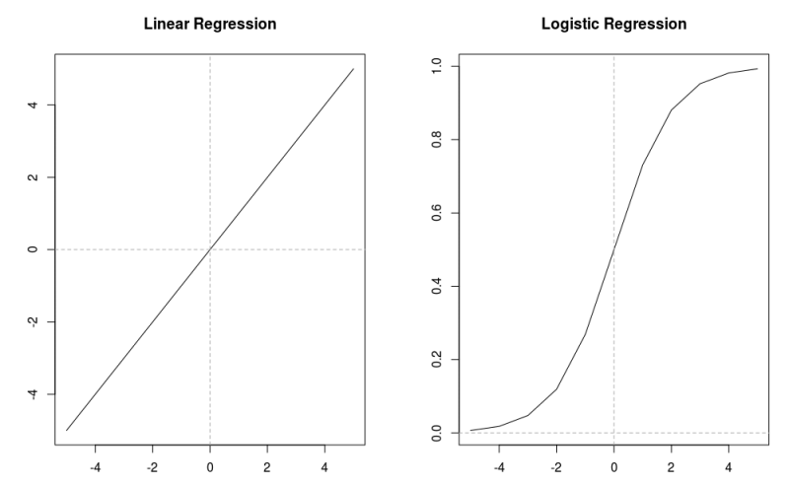
Linear vs Logistic
if you have greater numbers of 0s then it will be skewed downwards. Note that the number 0 on Y-axis represents that half of the counts of total number is on left and half of total count is on right, but it cannot be the case always.
Now the question arises, how do we map binary information of 1s and 0s to regression model which uses continuous variables? The reason we do that mapping is because we want our model to be capable of finding the probability of desired outcome being true. Keep in mind that the main premise of logistic regression is still based upon a typical regression model with a few methodical changes.
Now, to find the probability of desired outcome, two things we must always be followed.
1- That the probability cannot be negative, so we introduce a term called exponential in our normal regression model to make it logistic regression.
2- Since the probability can never be greater than 1, we need to divide our outcome by something bigger than itself.
And based on those two things, our formula for logistic regression unfolds as following:
1. Regression formula give us Y using formula Yi = β0 + β1X+ εi.
2. We have to use exponential so that it does not become negative and hence we get P = exp(β0 + β1X+ εi).
3. We divide that P by something bigger than itself so that it remains less than one and hence we get P = e( β0 + β1X+ εi)/e( β0 + β1X+ εi) +1.
4. After doing some calculations that formula in 3rd step can be re-written as log(p/(1-p)) = β0 + β1X+ εi.
5. log(p/(1-p)) is called the odds of probability. If you look closely, it is the probability of desired outcome being true divided by the probability of desired outcome not being true and this is called logit function.

Working:
When you calculate total number of 1s and 0s you can calculate the value of log(p/(1-p)) quite easily and we know that this value is equal to β0 + β1X+ εi. Now you can put that value into the formula P = e(β0 + β1X+ εi)/e( β0 + β1X+ εi) +1 and get the value of P. That P will be the probability of your outcome being TRUE based on some given parameters.
From a different perspective, let’s say you have your regression formula available with intercept and slope already given to you, you just need to put in the value of X to predict Y. But you know in logistic regression it doesn’t work that way, that is why you put your X value here in this formula P = e(β0 + β1X+ εi)/e( β0 + β1X+ εi) +1 and map the result on x-axis and y-axis. If the value is above 0.5 then you know it is towards the desired outcome (that is 1) and if it is below 0.5 then you know it is towards not-desired outcome (that is 0).

A little bit of touch to Exponent’s functionality
Let say you have invested a dollar somewhere. Now in a year it will grow 50% of its previous value, so in 2018 if it was $1 then in 2019 it becomes $1.5 and in 2020 it becomes $2.25. Why 2.25? Because $1 gave birth to 0.5$ and that 0.5$ starts earning its own interest which is 0.25 and as the time goes by the sprout of each sprout keeps earning its own interest and that it why we have that S-shape curve shown above.

Example
Things to keep in mind,
1- A linear regression method tries to minimize the residuals, that means to minimize the value of ((mx + c) — y)². Whereas a logistic regression model tries to predict the outcome with best possible accuracy after considering all the variables at hand.
2- It calculates the probability of each point in dataset, the point can either be 0 or 1, and feed it to logit function.
3- The coefficients we get after using logistic regression tell us how much that particular variables contribute to the log odds.
The source of the data is from UCLA which has 4 variable called admit, GRE score, GPA and rank of their undergrad school. Our aim is to build a model so that predict the probability of that student getting admit if we are given his profile.

df <- read.csv(“https://stats.idre.ucla.edu/stat/data/binary.csv”)
str(df)
We see that variable are either integer or number.

sum(is.na(df))

No null values

summary(df)
We can notice that there are a greater number of rejects than there are acceptance since the mean of variable admit is less than “0.5”.
xtabs(~ admit +rank ,data=df)
The xtabs() function creates contingency tables in frequency-weighted format. Use xtabs() when you want to numerically study the distribution of one categorical variable, or the relationship between two categorical variables. Categorical variables are also called “factor” variables in R
We do this to check if the admits are distributed well enough in each category of rank. If let’s say one rank has only 5 admit or reject information, then it will not be necessary to include that rank in analysis.
Now we run our logit function, but before that we also have to convert rank variable from integer to factor.

df$rank <- as.factor(df$rank)
logit <- glm(admit ~ gre+gpa+rank,data=df,family="binomial")
summary(logit)

Brief Interpretation
1- Each one-unit change in gre will increase the log odds of getting admit by 0.002, and its p-value indicates that it is somewhat significant in determining the admit.
2- Each unit increase in GPA increases the log odds of getting admit by 0.80 and p-value indicates that it is somewhat significant in determining the admit.
3- The interpretation of rank is different from others, going to rank-2 college from rank-1 college will decrease the log odds of getting admit by -0.67. Going from rank-2 to rank-3 will decrease it by -1.340.
4- The difference between Null deviance and Residual deviance tells us that the model is a good fit. Greater the difference better the model. Null deviance is the value when you only have intercept in your equation with no variables and Residual deviance is the value when you are taking all the variables into account. It makes sense to consider the model good if that difference is big enough.

Prediction
Let’s say a student have a profile with 790 in GRE,3.8 GPA and he studied from a rank-1 college. Now you want to predict the chances of that boy getting admit in future.

x <- data.frame(gre=790,gpa=3.8,rank=as.factor(1))
p<- predict(logit,x)
p
We see that there is 85% chance that this guy will get the admit.

Logistic regression is a predictive modelling algorithm that is used when the Y variable is binary categorical. That is, it can take only two values like 1 or 0. The goal is to determine a mathematical equation that can be used to predict the probability of event 1. Once the equation is established, it can be used to predict the Y when only the X’s are known.

1. Introduction to Logistic Regression
Earlier you saw what is linear regression and how to use it to predict continuous Y variables.
In linear regression the Y variable is always a continuous variable. If suppose, the Y variable was categorical, you cannot use linear regression model it.
So, what would you do when the Y is a categorical variable with 2 classes?
Logistic regression can be used to model and solve such problems, also called as binary classification problems.
A key point to note here is that Y can have 2 classes only and not more than that. If Y has more than 2 classes, it would become a multi class classification and you can no longer use the vanilla logistic regression for that.
Yet, Logistic regression is a classic predictive modelling technique and still remains a popular choice for modelling binary categorical variables.
Another advantage of logistic regression is that it computes a prediction probability score of an event. More on that when you actually start building the models.

2. Some real-world examples of binary classification problems
You might wonder what kind of problems you can use logistic regression for.
Here are some examples of binary classification problems:
- Spam Detection : Predicting if an email is Spam or not
- Credit Card Fraud : Predicting if a given credit card transaction is fraud or not
- Health : Predicting if a given mass of tissue is benign or malignant
- Marketing : Predicting if a given user will buy an insurance product or not
- Banking : Predicting if a customer will default on a loan.

3. Why not linear regression?
When the response variable has only 2 possible values, it is desirable to have a model that predicts the value either as 0 or 1 or as a probability score that ranges between 0 and 1.
Linear regression does not have this capability. Because, if you use linear regression to model a binary response variable, the resulting model may not restrict the predicted Y values within 0 and 1.
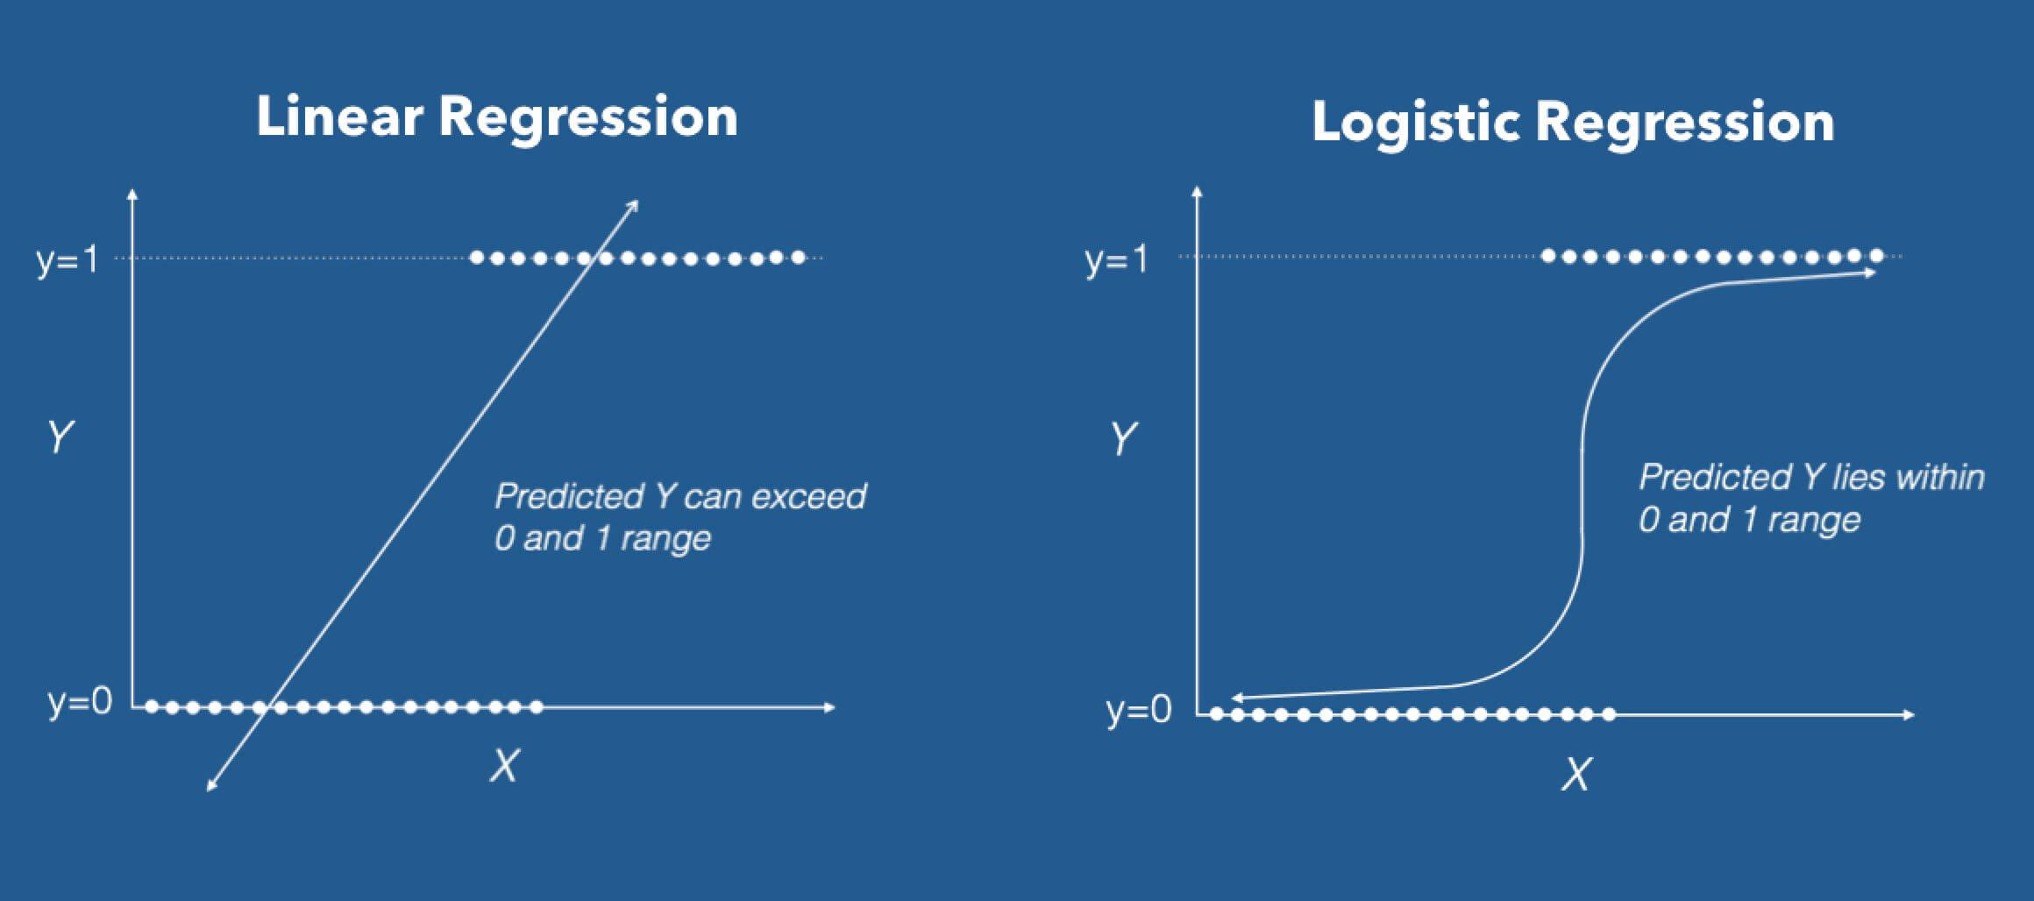
Linear vs Logistic Regression
This is where logistic regression comes into play. In logistic regression, you get a probability score that reflects the probability of the occurrence of the event.
An event in this case is each row of the training dataset. It could be something like classifying if a given email is spam, or mass of cell is malignant or a user will buy a product and so on.

4. The Logistic Equation
Logistic regression achieves this by taking the log odds of the event ln(P/1-P), where, P is the probability of event. So, P always lies between 0 and 1.
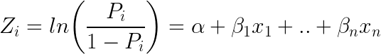
Taking exponent on both sides of the equation gives:
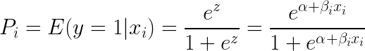
You can implement this equation using the glm() function by setting the family argument to "binomial".
# Template code
# Step 1: Build Logit Model on Training Dataset
logitMod <- glm(Y ~ X1 + X2, family="binomial", data = trainingData)

# Step 2: Predict Y on Test Dataset
predictedY <- predict(logitMod, testData, type="response")
Also, an important caveat is to make sure you set the type="response" when using the predict function on a logistic regression model. Else, it will predict the log odds of P, that is the Z value, instead of the probability itself.

Example
The in-built data set "mtcars" describes different models of a car with their various engine specifications. In "mtcars" data set, the transmission mode (automatic or manual) is described by the column am which is a binary value (0 or 1). We can create a logistic regression model between the columns "am" and 3 other columns - hp, wt and cyl.
# Select some columns form mtcars.
input <- mtcars[,c("am","cyl","hp","wt")]

print(head(input))

When we execute the above code, it produces the following result −
am cyl hp wt
Mazda RX4 1 6 110 2.620
Mazda RX4 Wag 1 6 110 2.875
Datsun 710 1 4 93 2.320
Hornet 4 Drive 0 6 110 3.215
Hornet Sportabout 0 8 175 3.440
Valiant 0 6 105 3.460

Create Regression Model
We use the glm() function to create the regression model and get its summary for analysis.
input <- mtcars[,c("am","cyl","hp","wt")]

am.data = glm(formula = am ~ cyl + hp + wt, data = input, family = binomial)

print(summary(am.data))
When we execute the above code, it produces the following result −
Call:
glm(formula = am ~ cyl + hp + wt, family = binomial, data = input)

Deviance Residuals:
Min 1Q Median 3Q Max
-2.17272 -0.14907 -0.01464 0.14116 1.27641

Coefficients:
Estimate Std. Error z value Pr(>|z|)
(Intercept) 19.70288 8.11637 2.428 0.0152 *
cyl 0.48760 1.07162 0.455 0.6491
hp 0.03259 0.01886 1.728 0.0840 .
wt -9.14947 4.15332 -2.203 0.0276 *
---
Signif. codes: 0 ‘***’ 0.001 ‘**’ 0.01 ‘*’ 0.05 ‘.’ 0.1 ‘ ’ 1

(Dispersion parameter for binomial family taken to be 1)

Null deviance: 43.2297 on 31 degrees of freedom
Residual deviance: 9.8415 on 28 degrees of freedom
AIC: 17.841

Number of Fisher Scoring iterations: 8

Conclusion
In the summary as the p-value in the last column is more than 0.05 for the variables "cyl" and "hp", we consider them to be insignificant in contributing to the value of the variable "am". Only weight (wt) impacts the "am" value in this regression model.

